**Creating a video game in python**



**Lecturer:**

**D4017_Jude Joseph Lamug Martinez, MCS**

**Made by:**

**2702350724_Rheynorich**

**Algorithm and Programming**

**Computer Science Faculty**

**Binus International University 2024/2024**

**Table of contents**

Table of contents……………………………………………………………………………………………………………………i

Abstract………………………………………………………………………………………………………………………………..ii

Chapter 1 – Project Description…………………………………………………………………………………………….1

* 1. Introduction…………………………………………………………………………………………………………………..1
  2. Idea Inspiration………………………………………………………………………………………………………………1
  3. How it works………………………………………………………………………………………………………………….1

Chapter 2 – Modules used

Chapter 3 – Essential Algorithms

Chapter 4 – Screenshots of Project

Chapter 5 – What have I learned

Chapter 6 – Source Code and Video Demo

References

**Abstract**

This documentation is my report on my Algorithm and Programming Final Project about making a video game using python. This report will explain the concepts and idea of my game and how I made the game using python. This report will also give detailed explanation on my code, how it works and how it functions altogether.

**Chapter 1 - Project Description**

* 1. **Introduction**

This project is made entirely out of Python coding language. The basic concept of this game is that you control a car driving along the road and there are obstacles in the way. You as a player need to move the car left or right to avoid those obstacles. If you hit the obstacle, you lose.

* 1. **Idea Inspiration**

The idea came as I was searching on Youtube for how to make a game in python. I saw the guy (Tech With Tim) make a game that had the same concept as my game. The guy’s code is the skeleton of my game and I changed the idea and added some extra features into the game.

* 1. **How it works**

My game simply just uses the keyboard as the controller of the car. All you have to do is press the left or right arrows to move the car away from the obstacles.

**Chapter 2 – Modules used**

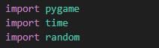

* **‘pygame’** is a module in python that is designed for writing games.
* **‘time’** is a module in python that provides various time-related functions. The main function of this module is to measure or manipulate time.
* **‘random’** is a module that generates random things. Example: random digits. The purpose of this module is to generate random numbers for how many obstacles appear in my game.

**Chapter 3 – The code**

There are 3 classes that is in the game

* Game class – Represents the main game loop and manages game-related functionalities such as player movement, obstacle generation, collision detection and handling user inputs
* Player class – This class represents the player’s car in the game. In this code, the player is represented using a ‘pygame.Rect’ object. The class would handle player movement and interaction
* Obstacle class – This class represents the obstacles (referred to as “Judes” in the code). Each obstacle is represented by a ‘pygame.Rect’ object with specific attributes such as position and size.

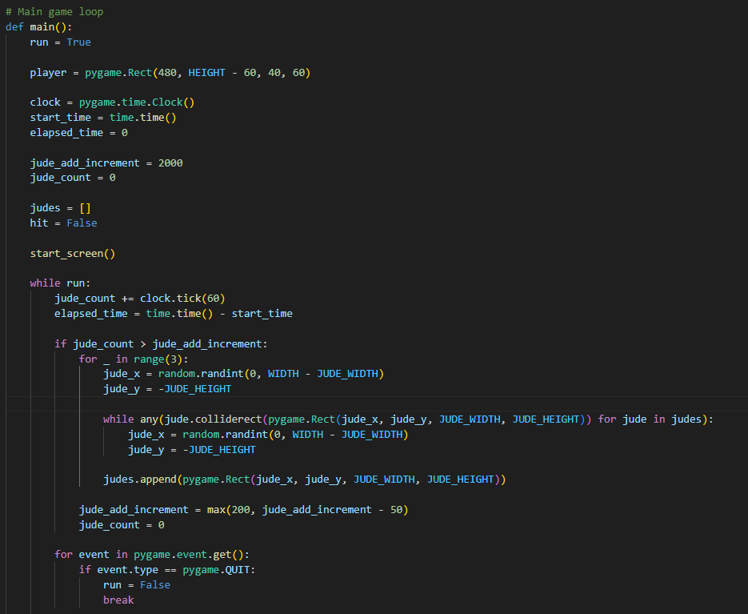The main game loop:

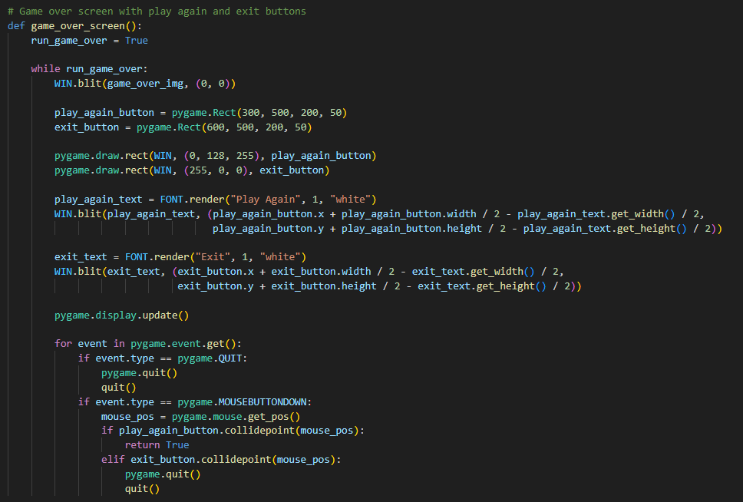Game over function:

Start screen function:

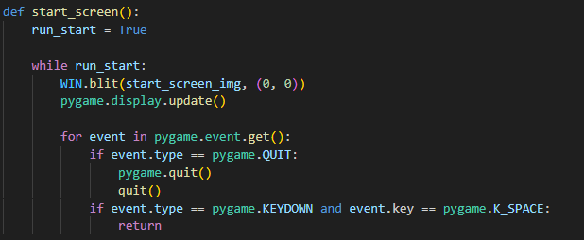

**Chapter 4 – Screenshots of project**

1. Start screen

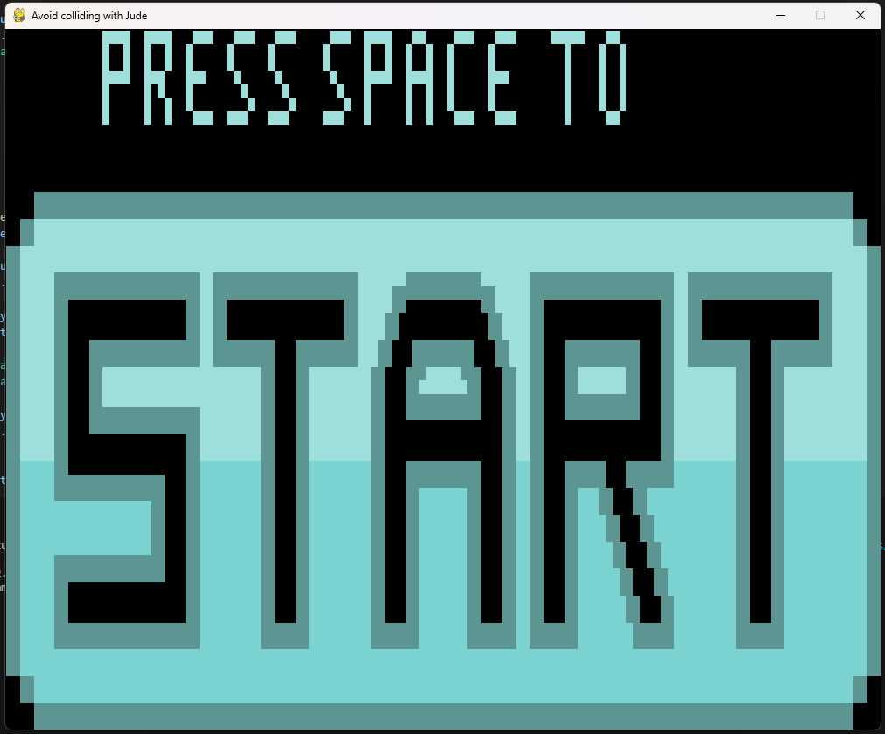

1. 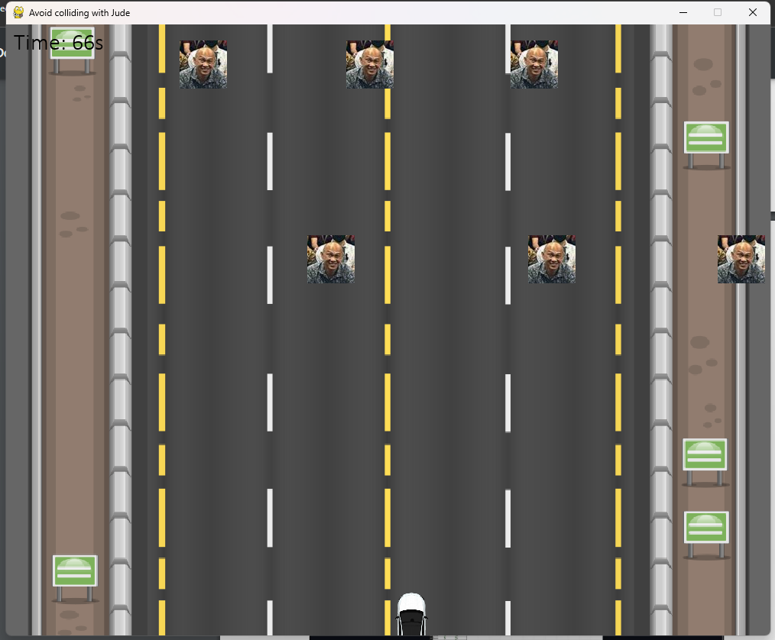Game screen
2. 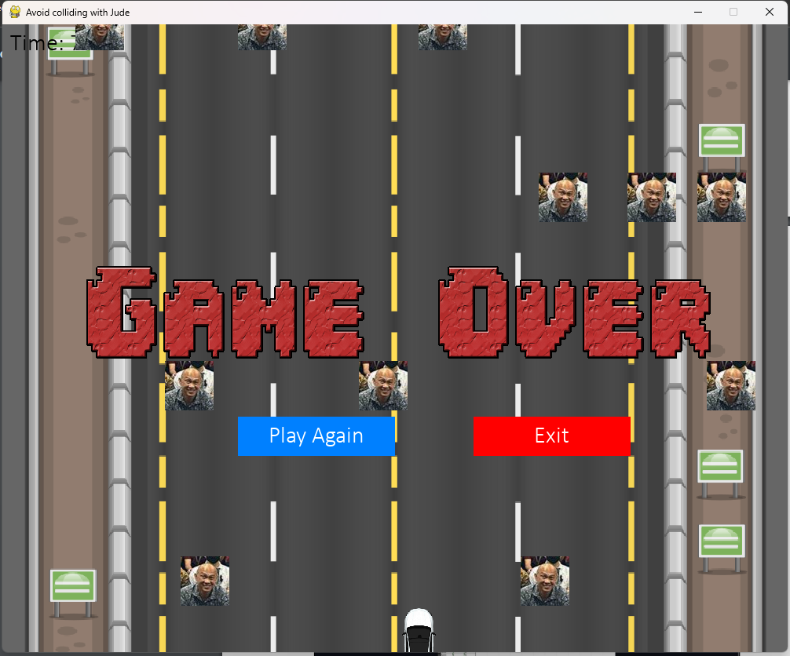Game over screen

**Chapter 5 – What have I learned**

While making this project, I have learnt many new things in python.

* I learned how to use modules in python like Pygame, random and time. Even though most of the coding I wrote were from the Youtube tutorial, I learned how the codes function and how the code correlates with each other.
* I also got to learn how to use pygame to code the input buttons such as the left and right arrows and the space button to activate the game.

And even though my project might not be the best, I was still exposed to many new techniques and functions while making this project. I might not be able to independently write my own code by myself yet but for now I accept this moment as I am experimenting and messing around with the code so that I can learn more in the future.

**Chapter 6 – Source Code and Video Demo**

Video Demo - <https://drive.google.com/file/d/1B0cCL9gYYBkOr74aUwON9UbamTXNxVpO/view?usp=sharing>

Source Code -

**Refrences**

<https://www.youtube.com/watch?v=waY3LfJhQLY> (Structure of the game)

<https://chat.openai.com/> (Help with any errors, code and implement my ideas and provided some explanations for my report)

<https://www.google.com/> (Background image and car image)